UNIFORM ORDER FORM
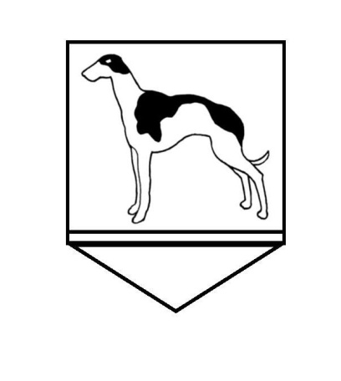

Name: ………………………………… Class: …………. Date ……………

Contact Telephone number: ………………………………………………..

Please complete the order form and hand it to the school office with the correct payment.

ALL CHEQUES SHOULD BE MADE PAYABLE TO “FLIXTON PRIMARY SCHOOL”. SORRY WE DO NOT TAKE CARD PAYMENTS

Item Required | Size  Required | Cost | Number  Required | Total Cost | Item Taken
School Logo Jumper  Size: 24” / 61cm  26” / 66cm  28” / 71cm  30” / 76cm |  | £15.50
School Logo Jumper  Size: 32” / 81cm  34” / 86cm  36” / 91cm |  | £18.50
School Logo Cardigan  Size: 24” / 61cm  26” / 66cm  28” / 71cm  30” / 76cm |  | £16.50
School Logo Cardigan  Size: 32” / 81cm  34” / 86cm  36” / 91cm |  | £19.00
School Tie  (Junior children only) | N/A | £4.00
Book bags (Nursery and Infant Dept only) | N/A | £5.50

TOTAL AMOUNT DUE
PAID (Cheque/Cash)
………………………………………………………………………………………….

RECEIPT (FOR OFFICE USE ONLY)

NAME _______________________________ CLASS ___________ DATE ______

Please find attached your uniform order. We acknowledge receipt of your payment for £

Signed ……………………………………………….

