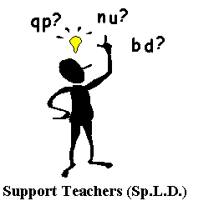
AUDITORY MEMORY

Table /number square
Concrete material
Prompt cards
Mind mapping
Spell checker
Tape recorder
Computer
Visual timetable
Lists
Topic words

Memory Aids

Learn to repeat directions to self before attempting to follow them.
Learn to take notes, keep a memory notebook.
Listen to information with your eyes closed.
Practice recalling meaningful number sequences.
Memorise poems, songs, stories etc.
Listen to what is to be written first then write it.
It is ok to ask for repetition and help.
Make up an organisational system, colour coding, folders, visual timetable,
Pupil tips

Keep instructions short and issue one at a time.
Break down longer instructions into smaller chunks.
Support verbal information with visual prompts.
Check pupil is looking and listening before given instructions.
Repeat key words and phrases.
Keep information concise and in manageable stages.
Reduce and restructure complex tasks. Consider the amount of processes required.
Check during lesson that pupil remembers given task.
Allow extra time to think through what has been said.
Give time to find words and to form what is to be said.
Check understanding by asking to retell what was said.
Sit near the teacher for discrete checking.
Limit copying, provide worksheets or photocopies.
Older pupils may use a Dictaphone.
Encourage the use of memory aids for writing, spelling and number.
Use ICT.

Classroom tips

Working memory is short term, temporary storage.
7 pieces of information at a time can be retained for approximately 20 secs.

Long term memory store holds learnt knowledge and past experiences not currently being used but can be retrieved.
Memory fades with time.
Repeating information can prolong its existence within the memory.

Phonological - Storing and manipulation of all speech based information begins to fade after approximately 2 sec.
Theory

trouble recalling what has been said
trouble following instructions and directions
trouble remembering what they have said
delay and hesitation in responding to questions
difficulty remembering what has been heard, especially the sequential use of words in sentences
remembers for a short time but cannot remember the sequence of events heard long enough to learn them successfully
difficulty remembering the sequence of syllables to form words
trouble keeping the place
class work not completed within a given deadline or rushes through work
trouble maintaining focus and attention
despite age appropriate skills
self-esteem and confidence may often be low
passive within class activities
memory overload and task abandonment

Recognise

